**ASSIGNMENT 1**

**1. What is SDLC?**

:- SDLC is stand for software devlopment life cycle.there are 6 stape available in SDLC.

1) Requirement gathering

2) Analysis

3) Design

4) Implementation

5) Testing

6) Maintenance.

**2. What is software testing?**

:- Software testing is process used to identify correctness, completeness and quality of devloped computer sodtware and web sites.

**3. What is agile methodology?**

:- Agile model is combination of iterative and incremental process models. agile model is suitable for fixed and changing requirement.

**4. What is SRS?**

:- SRS is stand for software requirements specification.

**5.What is oops?**

:- Object oriented programming is a concepts of object , class , abstaction , encapsulation , inheritance and polymorphism.

**6. Write basic concepts of oops**

:- 1) Object

2) Class

3) Abstaction

4) Encapsulation

5) Inheritance

6) Polymorphism

**7. What is object?**

:- object is any entity which has own state and behaviour is called object.

**8. What is class?**

:- class is a collection of objects.

**9. What is encapsulation?**

:- encapsulation is wrapping of data or binding a data.

**10. What is inheritance?**

:- when one objects acquire all the properties and behaviour of parent class is called inheritance.

**11. What is polymorphism?**

:- polymorphism is allows different objects to respond to the same message in different ways.

**12. Draw usecase on online book shopping**

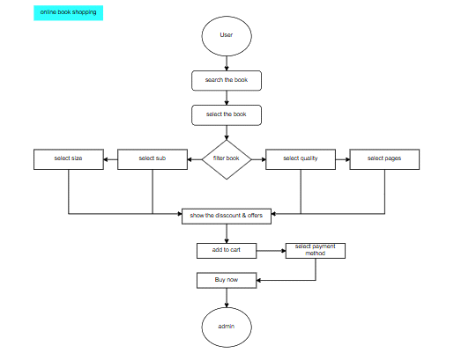

**13. Draw usecase on online bill payment system**

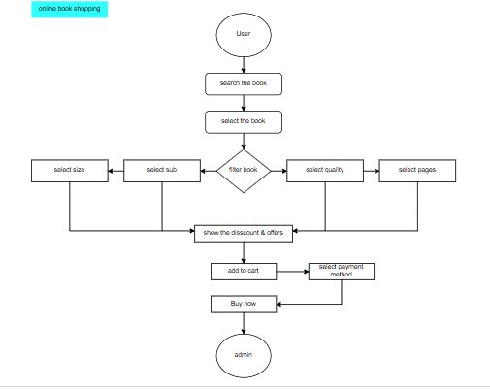

**14. Write SDLC phases with basic introduction**

:- Requirement gathring -customer needs

Analysis -model data anlysis

Design -model specification and designed

Implementation -data implement and model solution

Testing -software testing and solution

Maintenance -defect repair and requirement solution

**15. Explain phases of the waterfall model**

:- There are the phases of the waterfall model

- Requirments - this includes client's need and requriments.

- Analysis - this includes detailed requirements of document.

- Design - this create the technical plan as blueprint.

- Implementation - the design is developed and tested individually during this.

- Testing - this includes testing for faults and perfomance issues.

- Maintenance - this phase is for ongoing support and bug fixes.

**16. Write phases of spiral model**

:- there are the phases of the spiral model

- Planning - determination of objective,alternatives and constaraints.

- Risk analysis - analysis of alternatives and identification of risks.

- Engineering - development of the next level product.

- Customer evolution - assessment of the results of engineering.

**17. Write agile manifesto principls**

:- - Customer satisfaction and delivery

- Avoid of requirement features

- Working software deliver

- Collobration the business developers

- Successful comunication

- Enable face to face interaction

- Agile processes to support a consistent development.

**18. Explain working methodology of agile model and also write pros and cons.**

:- Requirments analysis -> Design -> Development -> Quality assurance -> Deployment.

- Agile model pros and cons:

Pros:

- Increase flexibility

- Faster time to market

- Higher satisfaction

- Improved collaboration

- Better risk management

- Best product quality

Cons:

- Reduce predictrability

- Lack of comprehensive documentation

- Potential scope creepe

- Not for every project

**19. Draw usecase on online shopping product using COD.**

:-

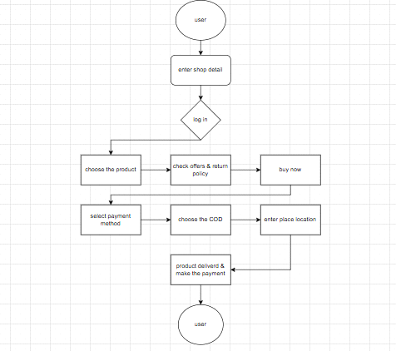

**20. Draw usecase on online shopping product using payment gateway.**

:-

